

| **TITLE:**  Program to print patterns |
| --- |

**AIM:** Program to print patterns for ‘n’ rows using nested loops. **______________________________________________________________________**

**Expected OUTCOME of Experiment:** The program takes the number of rows to be printed as the input by the user and prints the pattern accordingly.

**_____________________________________________________________________**

**Books/ Journals/ Websites referred:**

1. Programming in C, second edition, Pradeep Dey and Manas Ghosh, Oxford University Press.
2. Programming in ANSI C, fifth edition, E Balagurusamy, Tata McGraw Hill.
3. Introduction to programming and problem solving , G. Michael Schneider ,Wiley India edition.
4. [**http://cse.iitkgp.ac.in/~rkumar/pds-vlab/**](http://cse.iitkgp.ac.in/~rkumar/pds-vlab/)

**_____________________________________________________________________**

**Problem Definition:**

The program is to print a pattern as given by the user. The program makes use of a nested loop to print a pattern of characters, numbers or alphabets.

**Example:**

Input: Number of rows = 4

Output:

1

1 2

1 2 3

1 2 3 4

**Algorithm:**



**Implementation details:**

#include<stdio.h>

#include<conio.h>

void main()

{

int r,i,j;

printf("Enter the number of rows to be printed: ");

scanf("%d",&r);

for (j=1;j<=r;j++)

{

for (i=1;i<=j;i++)

{

printf("%d ",i);

}

printf("\n");

}

}

**Output(s):**

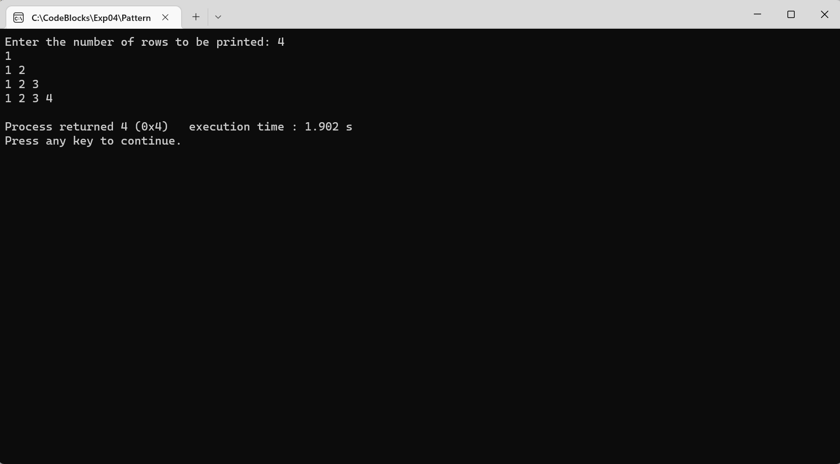

**Conclusion:**

The program could thus take the number of rows to be printed as the input and printed the pattern accordingly.

**Post Lab Descriptive Questions**

Write a program to print the following:

1

2 4

3 6 9

4 8 12 16

5 10 15 20 25

6 12 18 24 30 36

7 14 21 28 35 42 49

8 16 24 32 40 48 56 64

9 18 27 36 45 54 63 72 81

10 20 30 40 50 60 70 80 90 100

Program:

#include<stdio.h>

#include<conio.h>

void main()

{

int i,j;

for (i=1;i<=10;i++)

{

for (j=1;j<=i;j++)

{

printf("%d ",i*j);

}

printf("\n");

}

}

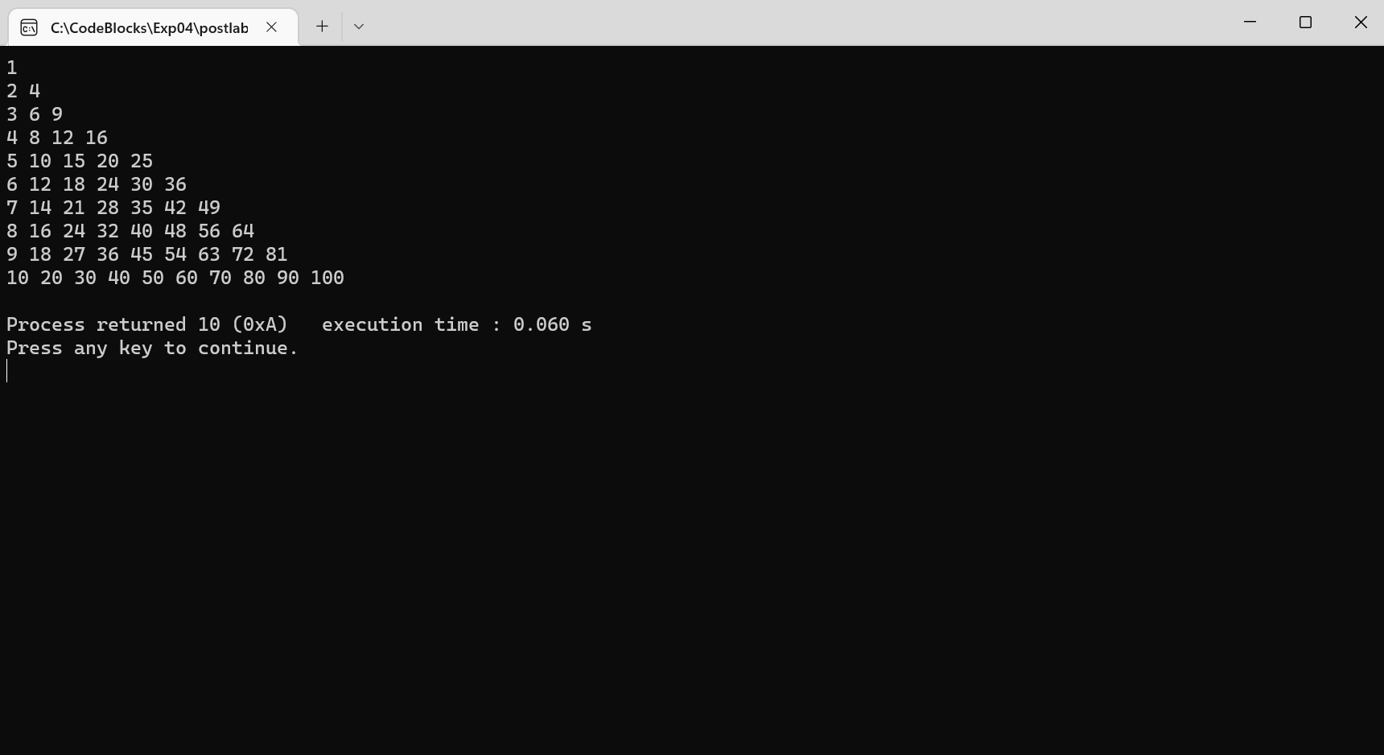

**Date: _____________ Signature of faculty in-charge**